CONFERENCE ROOM BOOKING

Introduction:
This application does online conference room booking on date and time basis for the people who are working in an organization and who needs the conference room for their organizational activities. It also helps in booking devices needed for conference such as amplifier, video switch and projector etc.

Existing System:
If there is no system for the booking of the conference room then the following problems are going to face by the employs of the organization.

- Each employ need to personally approach the in-charge of the conference room for the booking by leaving their present work.
- The conference room in-charge need to maintain all these requests manually and always there may be a chance of doing mistake.
- If two three employ reach the conference room with out proper booking time is wasted and misunderstandings takes place among the employs
- It takes more time to know the status of the conference room due to manual approach.
- There may be chance to show bias on some employs while doing booking conference room.
- Since supporting devices list is not properly maintained, there may be a chance of doing mistake.

Proposed System:
A centralized database is maintained with the details of the conference rooms and the devices needed for conducting conferences such as amplifier, video switch, projector etc. This application is developed by using online techniques so that the details of the conference rooms are available in the screen from any desktop. So that each employ can see the list of conference rooms existing in the organization and the status of those conference rooms. The employ of the organization may get an idea about the availability of the conference rooms and accordingly he/she can book the conference rooms on date and time based. More over it is possible to book the other supported devices needed for the conference such as amplifiers, video switch, projector etc. All the data is stored centrally in the database and it is visible to all the employs in a transparent manner. So there is no change for the mischief or bias in booking the conference rooms and other required supporting equipment.

Advantages:
The proposed system is having the following advantages
- The entire conference rooms list is visible to every one.
- The status of each conference room can be seen by every one
- No confusion in booking conference rooms and other equipment.
- Since they themselves are booking conference rooms no chance of any bias or partiality in booking the conference rooms
- No time is wasted in booking the conference rooms
- Effective use of conference rooms is possible
- Good co-ordination and co-operation is established among the employs of the organization

Objective:
The object of this project is to book the conference room and other supporting equipment without any bias and time waste or confusion.

Scope:
This application deals with the booking of the conference rooms and equipments needed to conduct conferences only.

Functions of the application:
- Maintaining conference rooms list
- Maintaining status of the conference rooms
- Providing details of the booking based on date
- providing conference room booking
- providing supporting devices booking
- Report generation

Modules:
- User Management Module
This module adds a new user, updates an existing user and deletes a user and displays the details of a user. In order to operate the application every user must have a user id and password.

- Conference Rooms Module
All the conference rooms that are belonging to the company for the booking are managed by this module. It adds a conference room, deletes a conference room etc.

- Booking Module
This module books a conference room when an employ wants to conduct conference on date and time based. This notes all the needed information such as who booked, purpose of booking, required date and time, equipments needed etc.

- Sending Confirmation Module
It sends the confirmation to the booked employs

- Reports Module
It generates various reports such as
  - Conference Rooms list
  - Available conference rooms list
  - booked conference rooms list
  - booking details of particular conference room
System Requirements:

Hardware Requirement:

Processor : Pentium IV

HDD : 500 GB

RAM : 2 GB

Intranet connections

Software Requirements:

Operating System : Windows 2003/XP

Front End : JSP, HTML

Language : Java

Database : Oracle

System Analysis:
FEASIBILITY STUDY
Feasibility considerations:
The feasibility study is carried out to find whether the proposed system can be developed and implemented without any problem. The following feasibility is considered for the project in order to ensure that the project is viable and it does not have any major obstructions. In this regard technical, behavioral, and economic feasibility are analyzed.

Technical feasibility:
Technical feasibility such as whether the necessary technology exist to do what is suggested and if the equipment have the capacity to hold data required by the use of new system. Also any technical guarantees of accuracy, reliability, ease of access, data security could be provided etc.

Behavioral Feasibility:
People are inherently resistant to change and computers have known to facilitate changes. Every department welcomes the idea of computerization. But the resistance will be from the operators who are involved in the existing system or manual system.

Behavioral Feasibility is also studied like whether the changes made to the system facilitates the user and if he is able to adapt to the change made by introducing computers. An agreement is made between management and staff so that computerizing system will be installed step by step by giving training to existing staff members only.

Economic Feasibility:
Economic feasibility like if the existing resources are sufficient introducing. Any extra h/w required should be affordable in terms of cost. Also can the system be built within the specified time interval? Establish cost and schedule constraints. Defining functions for h/w, s/w people. Create system definition that forms a foundation for all subsequent engineering work.

SYSTEM DESIGN
Outputs from computer systems are required primarily to communicate the results of processing to users. They are also used to provides a permanent copy of the results for later consultation. The various types of outputs in general are:
- External Outputs, whose destination is outside the organization
- Internal Outputs whose destination is with in organization and they are the user’s main interface with the computer.
- Operational outputs whose use is purely with in the computer department.
- Interface outputs, which involve the user in communicating directly with

Output Definition

The outputs should be defined in terms of the following points:
. Type of the output
. Content of the output
. Format of the output
. Location of the output
. Frequency of the output
. Volume of the output
. Sequence of the output

It is not always desirable to print or display data as it is held on a computer. It should be decided as which form of the output is the most suitable.

For Example
. Will decimal points need to be inserted?
. Should leading zeros be suppressed.

Output Media:
In the next stage it is to be decided that which medium is the most appropriate for the output. The main considerations when deciding about the output media are:

.The suitability for the device to the particular application.
.The need for a hard copy.
.The response time required.
.The location of the users
.The software and hardware availability.

Keeping in view the above description the project is to have outputs mainly coming under the category of internal outputs. The main outputs desired according to the requirement specification are:

The outputs were needed to be generated as a hot copy and as well as queries to be viewed on the screen. Keeping in view these outputs, the format for the output is taken from the outputs, which are currently being obtained after manual processing. The standard printer is to be used as output media for hard copies.

INPUT DESIGN

Input design is a part of overall system design. The main objective during the input desings is as given below:

- To produce a cost-effective method of input.
- To achieve the highest possible level of accuracy.
- To ensure that the input is acceptable and understood by the user.

INPUT STAGES:

The main input stages can be listed as below:
- Data recording
- Data transcription
- Data conversion
- Data verification
- Data control
- Data transmission
- Data validation
- Data correction

INPUT TYPES:
It is necessary to determine the various types of inputs. Inputs can be categorized as follows:
- External inputs, which are prime inputs for the system.
- Internal inputs, which are user communications with the system.
- Operational, which are computer department’s communications to the system?
- Interactive, which are inputs entered during a dialogue.

INPUT MEDIA:
At this stage choice has to be made about the input media. To conclude about the input media consideration has to be given to;

- Type of input
- Flexibility of format
- Speed
- Accuracy
- Verification methods
- Rejection rates
- Ease of correction
- Storage and handling requirements
- Security
- Easy to use
- Portabilility

Keeping in view the above description of the input types and input media, it can be said that most of the inputs are of the form of internal and interactive. As Input data is to be the directly keyed in by the user, the keyboard can be considered to be the most suitable input device.

ERROR AVOIDANCE
At this stage care is to be taken to ensure that input data remains accurate form the stage at which it is recorded upto the stage in which the data is accepted by the system. This can be achieved only by means of careful control each time the data is handled.

ERROR DETECTION
Even though every effort is make to avoud the occurrence of errors, still a small proportion of errors is always likely to occur, these types of errors can be discovered by using validations to check the input data.

DATA VALIDATION
Procedures are designed to detect errors in data at a lower level of detail. Data validations have been included in the system in almost every area where there is a possibility for the user to commit errors. The system will not accept invalid data. Whenever an invalid data is keyed in, the system immediately propts the user and the user has to again key in the data and the system will accept the data only if the data is correct. Validations have been included where necessary.

The system is designed to be a user friendly one. In other words the system has been designed to communicate effectively with the user. The system has been designed with pop up menus.

USERINTERGFACE DESIGN
It is essential to consult the system users and discuss their needs while designing the user interface:

USER INTERFACE SYSTEMS CAN BE BROADLY CLASIFIED AS:

- User initiated interface the user is in charge, controlling the progress of the user/computer dialogue. In the computer-initiated interface, the computer selects the next stage in the interaction.
- Computer initiated interfaces
In the computer initiated interfaces the computer guides the progress of the user/computer dialogue. Information is displayed and the user response of the computer takes action or displays further information.

USER_INITIATED INTERGFACES
User initiated interfaces fall into tow approximate classes:
- Command driven interfaces: In this type of interface the user inputs commands or queries which are interpreted by the computer.

- Forms oriented interface: The user calls up an image of the form to his/her screen and fills in the form. The forms oriented interface is chosen because it is the best choice.

COMPUTER-INITIATED INTERFACES
The following computer – initiated interfaces were used:
- The menu system for the user is presented with a list of alternatives and the user chooses one; of alternatives.
- Questions – answer type dialog system where the computer asks question and takes action based on the basis of the users reply.
Right from the start the system is going to be menu driven, the opening menu displays the available options. Choosing one option gives another popup menu with more options. In this way every option leads the users to data entry form where the user can key in the data.

ERROR MESSAGE DESIGN:
The design of error messages is an important part of the user interface design. As user is bound to commit some errors or other while designing a system the system should be designed to be helpful by providing the user with information regarding the error he/she has committed.

This application must be able to produce output at different modules for different inputs.

Performance Requirements:
Performance is measured in terms of the output provided by the application.

Requirement specification plays an important part in the analysis of a system. Only when the requirement specifications are properly given, it is possible to design a system, which will fit into required environment. It rests largely in the part of the users of the existing system to give the requirement specifications because they are the people who finally use the system. This is because the requirements have to be known during the initial stages so that the system can be designed according to those requirements. It is very difficult to change the system once it has been designed and on the other hand designing a system, which does not cater to the requirements of the user, is of no use.

The requirement specification for any system can be broadly stated as given below:

- The system should be able to interface with the existing system
- The system should be accurate
- The system should be better than the existing system

The existing system is completely dependent on the staff to perform all the duties.

Tables Used:
The following Tables are needed to develop this application:
- conference rooms table
This table maintain the details of conference room no, its seating capacity, its features such as facilities available in the conference room, its status etc.

- Other equipments table
It maintains the details of the conference room supported equipment details such as amplifiers, video switches, projects etc.
- bookings table
This table maintains the details of the employs who booked the conference room, date and time the conference room is needed etc.
- employs table
This table maintains the details of the employ with the user id, password. The employ can login in to the system with the help of this user is and password only.

USE CASE DIAGRAM

ADMIN USE CASE
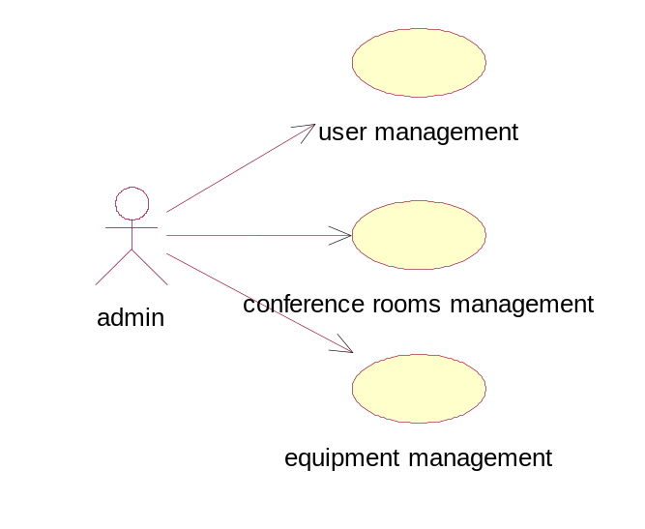

EMPLOY USE CASE
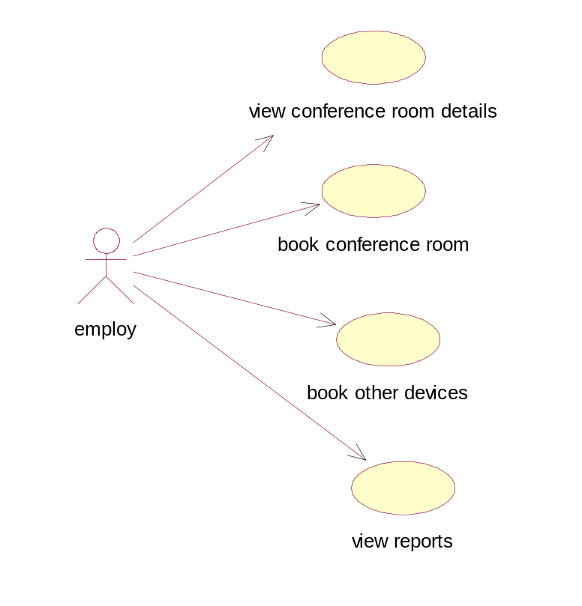

SEQUENCE DIAGRAM
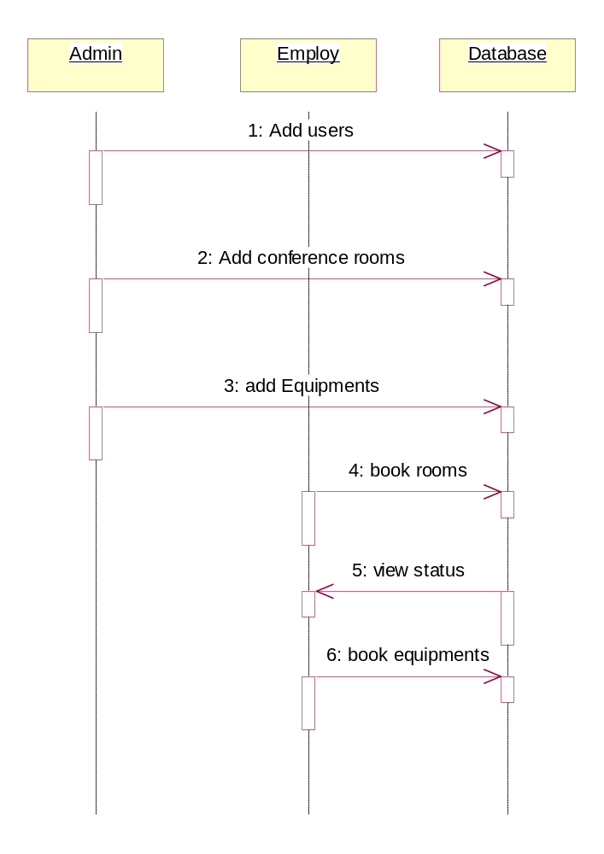

LEVEL 0 DFD

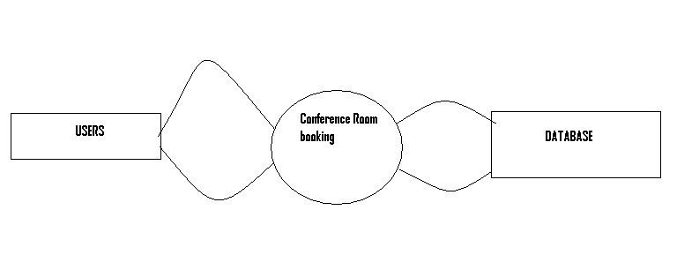

LEVEL-1 DFD FOR ADMIN

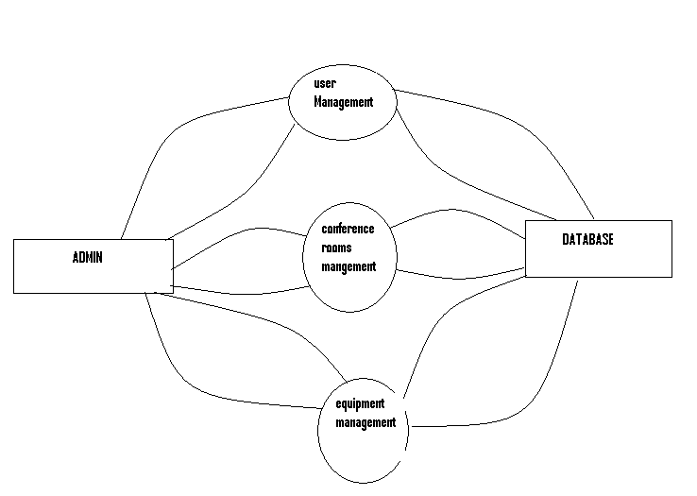

LEVEL-1 EMPLOY
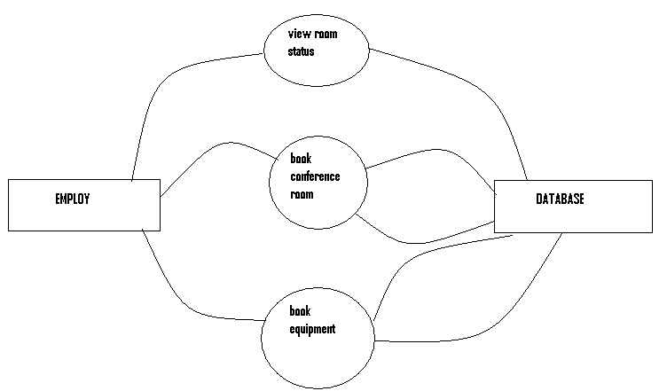

ER DIAGRAM
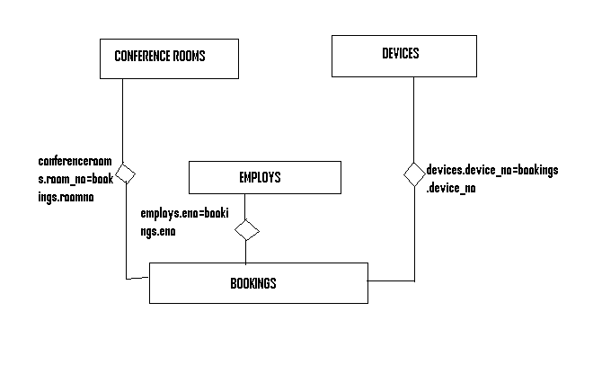
Final conclusion of the project
It is finally concluded that this application is very useful to organize the conference rooms most efficiently without any confusion. This helps proper utilization of the conference rooms.

